

[2009-07] Adding Permission for Mobile App

**Development Plan**

내용

1. Plan history 2

2. Policy Definitions 3

3. Requirements Definitions (Functions Definitions) 4

4. UI Design 5

4.1 Phone, Camera, Contact 5

4.2 Storage, location 6

4.3 After installation, mark the items agreed by the customer. 7

# Plan history

|  |  |  |  |  |
| --- | --- | --- | --- | --- |
| Version | Date | Author | Type | Contents |
| 1.0 | 2020.10.26 | Max |  |  |
|  |  |  |  |  |
|  |  |  |  |  |
|  |  |  |  |  |
|  |  |  |  |  |
|  |  |  |  |  |
|  |  |  |  |  |

# 2. Policy Definitions

|  |  |  |
| --- | --- | --- |
| ID | Policy Name | Policy Contents |
|  |  |  |
|  |  |  |
|  |  |  |
|  |  |  |
|  |  |  |
|  |  |  |
|  |  |  |

# 3. Requirements Definitions (Functions Definitions)

|  |  |  |
| --- | --- | --- |
| ID | Requirement Title | Requirement Contents |
| REQ-001 | Location Information | Customers must agree on location information in order to use the GME app. |
| REQ-002 | Storage | Customers must agree on storage space in order to use the GME app. |
| REQ-003 | Call | Customers must agree to a phone call in order to use the GME app. |
| REQ-004 | Contacts | Customers must agree to the address book in order to use the GME app. |
| REQ-005 | Camera | Customers must agree to the camera in order to use the GME app. |
| REQ-006 | Initial Installation | When the initial app is installed, the customer must be asked for approval.  If even one is not approved, you cannot run the app. |
| REQ-007 | Re-Approval | If the customer changes the value after approval,  The customer shall request approval again.  If even one is not approved, you cannot run the app. |
| REQ-008 | Confirm | When the customer installs the app and runs the app for the first time, it should show the approved items. |
|  |  |  |
|  |  |  |
|  |  |  |
|  |  |  |
|  |  |  |

# 4. UI Design

## 4.1 Phone, Camera, Contact

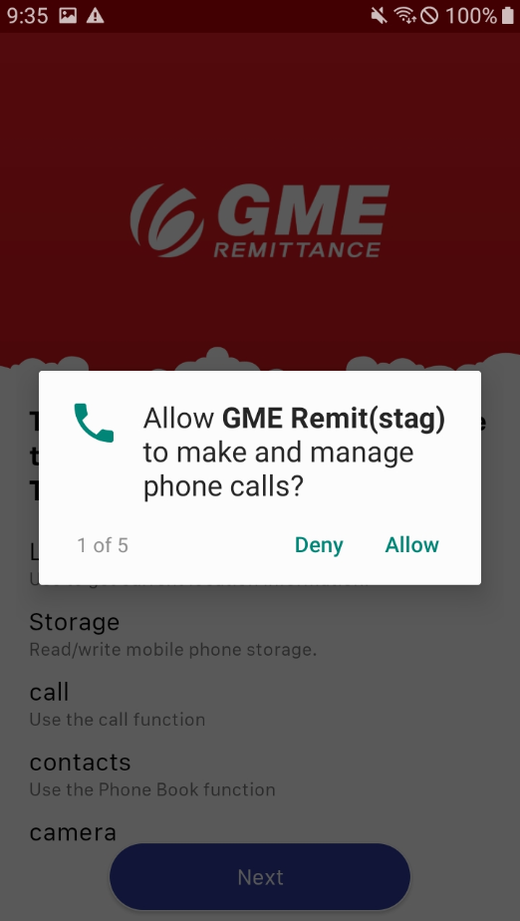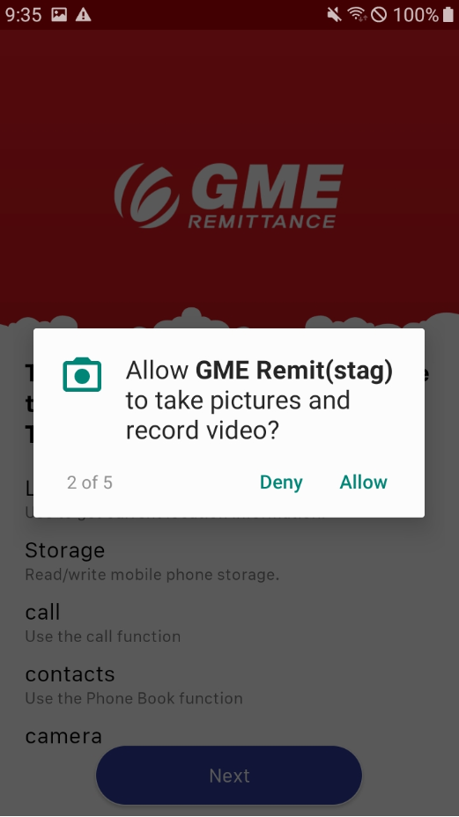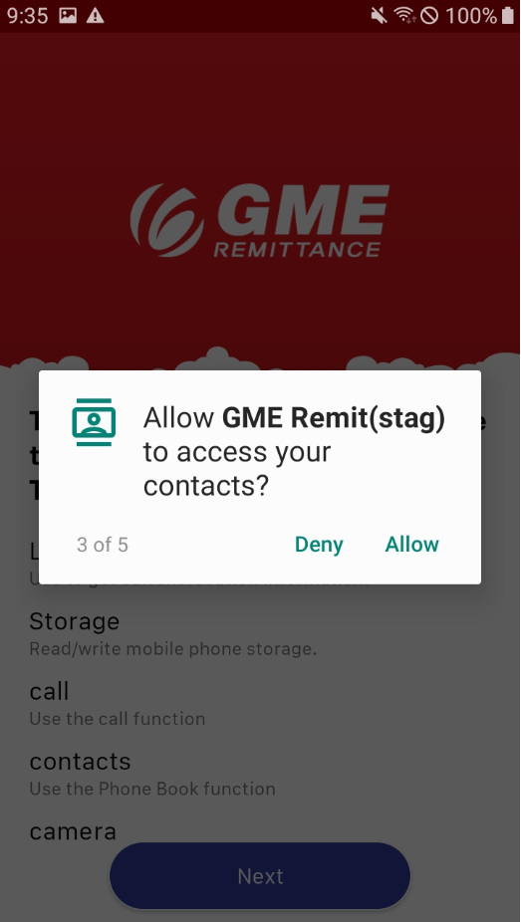

## 4.2 Storage, location

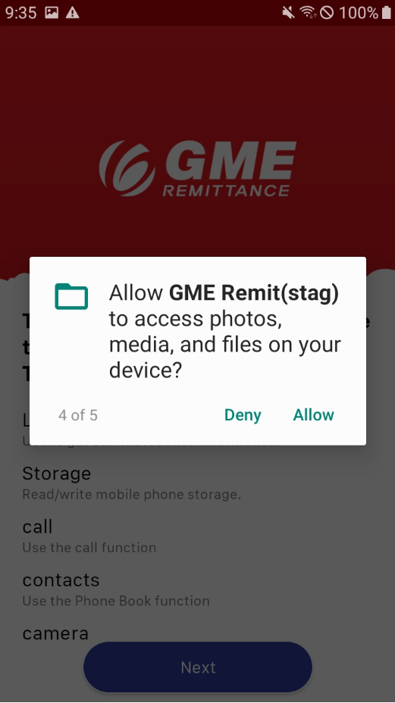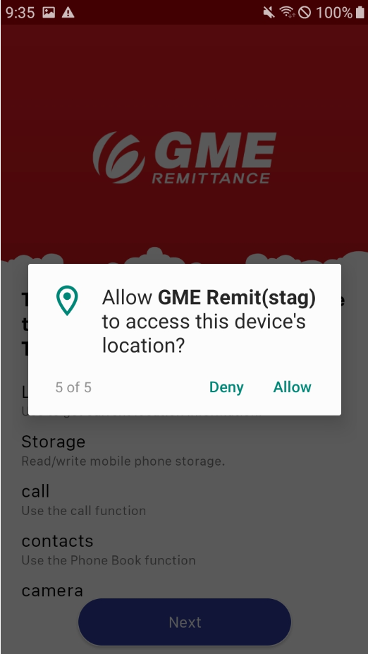

## 4.3 After installation, mark the items agreed by the customer.

